Acceleration Worksheet. Name: _________________________
Date: ______________
14.2 Acceleration
Acceleration is the rate of change in the speed of an object. To determine the rate of acceleration, you use the formula below. The units for acceleration are meters per second per second or m/s2 or m s-2
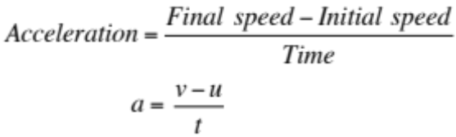
A positive value for acceleration shows speeding up, and negative value for acceleration shows slowing down. Slowing down is also called deceleration.
The acceleration formula can be rearranged to solve for other variables such as final speed (v) and time (t).
NB: At rest or come to rest means zero speed.
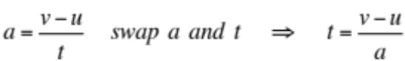

EXAMPLES
1. A skater increases her velocity from 2.0 m/s to 10.0 m/s in 3.0 seconds. What is the skater’s acceleration?
Looking for  Acceleration of the skater | Solution  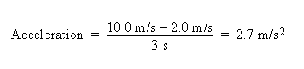  The acceleration of the skater is 2.7 meters per second per second.
Given
Beginning speed = 2.0 m/s
Final speed = 10.0 m/s
Change in time = 3 seconds
Relationship
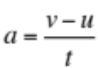
2. A car accelerates at a rate of 3.0 m/s2. If its original speed is 8.0 m/s, how many seconds will it take the car to reach a final speed of 25.0 m/s?
Looking for  The time to reach the final speed. | Solution  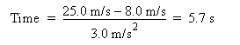`  The time for the car to reach its final speed is 5.7 seconds.
Given
Beginning speed = 8.0 m/s; Final speed = 25.0 m/s
Acceleration = 3.0 m/s2
Relationship
Exercise (Calculating Acceleration) Name: _________________________
1. While traveling along a highway a driver slows from 24 m/s to 15 m/s in 12 seconds. What is the automobile’s acceleration? (Remember that a negative value indicates a slowing down or deceleration.)

2. A parachute on a racing dragster opens and changes the speed of the car from 85 m/s to 45 m/s in a period of 4.5 seconds. What is the acceleration of the dragster?

3. The table below includes data for a ball rolling down a hill. Fill in the missing data values in the table and determine the acceleration of the rolling ball.
Time (seconds) | Speed (km/h)
0 (start) | 0 (start)
2 | 3
 | 6
 | 9
8
10 | 15
Acceleration = _______________________________________________________________
4. A car traveling at a speed of 30.0 m/s encounters an emergency and comes to a complete stop. How much time will it take for the car to stop if it decelerates at -4.0 m/s2?

5. If a car can go from 0 to 60 km/hr in 8.0 seconds, what would be its final speed after 5.0 seconds if its starting speed were 50 km/hr?

6. A cart rolling down an incline for 5.0 seconds has an acceleration of 4.0 m/s2. If the cart has a beginning speed of 2.0 m/s, what is its final speed?

7. A helicopter’s speed increases from 25 m/s to 60 m/s in 5 seconds. What is the acceleration of this helicopter?

8. As she climbs a hill, a cyclist slows down from 25 mi/hr to 6 mi/hr in 10 seconds. What is her deceleration?

9. A motorcycle traveling at 25 m/s accelerates at a rate of 7.0 m/s2 for 6.0 seconds. What is the final speed of the motorcycle?

10. A car starting from rest accelerates at a rate of 8.0 m/s/s. What is its final speed at the end of 4.0 seconds?

11. After traveling for 6.0 seconds, a runner reaches a speed of 10 m/s. What is the runner’s acceleration?

12. A cyclist accelerates at a rate of 7.0 m/s2. How long will it take the cyclist to reach a speed of 18 m/s?

13. A skateboarder traveling at 7.0 meters per second rolls to a stop at the top of a ramp in 3.0 seconds. What is the skateboarder’s acceleration?

